- Configure Classic Load balancer.

1. Task Title

Configure AWS Classic Load Balancer (CLB)

2. Objective

To configure an AWS Classic Load Balancer that distributes incoming traffic across multiple EC2 instances to ensure high availability and fault tolerance.

3. Prerequisites

Before starting, ensure the following are available:

* An active AWS account
* At least **two EC2 instances** running (same VPC and AZs as required)
* EC2 instances have a **web application** running (e.g., Apache/Nginx on port 80)
* Proper **security group** allowing inbound traffic on required ports (e.g., 80/443)
* IAM user/role with permissions for EC2 and Elastic Load Balancing

4. Step-by-Step Implementation

### Step 1: Navigate to Load Balancers

1. Log in to the AWS Management Console
2. Go to **EC2 → Load Balancers**
3. Click **Create Load Balancer**

### Step 2: Select Load Balancer Type

1. Choose **Classic Load Balancer**
2. Click **Create**

### Step 3: Define Load Balancer Details

1. Enter a **Load Balancer Name**
2. Choose **Internet-facing** or **Internal**
3. Select the **VPC**
4. Add **Listeners** (e.g., HTTP on port 80 → instance port 80)
5. Select the required **Availability Zones**

### Step 4: Configure Security Groups

1. Assign an existing security group **or** create a new one
2. Ensure inbound rules allow traffic (e.g., HTTP/HTTPS)

### Step 5: Configure Health Checks

1. Set Ping Protocol (HTTP/TCP)
2. Set Ping Port (e.g., 80)
3. Define Ping Path (e.g., `/index.html`)
4. Configure healthy and unhealthy thresholds

### Step 6: Add EC2 Instances

1. Select the EC2 instances to attach
2. Ensure instances are in the same VPC
3. Click **Add to Registered**

### Step 7: Review and Create

1. Review all configurations
2. Click **Create Load Balancer**

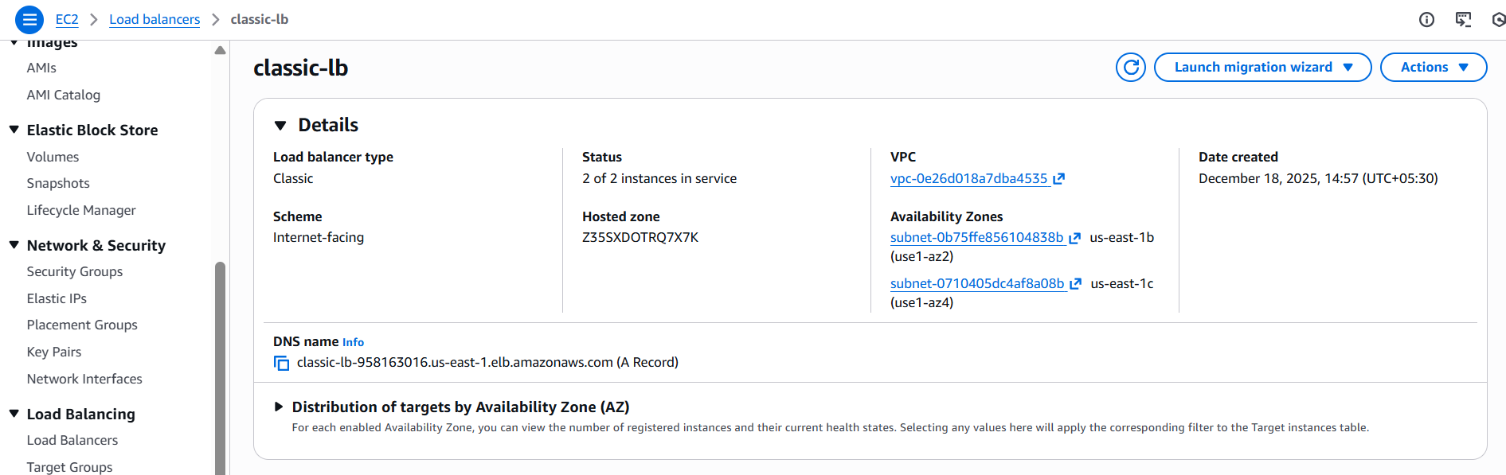

5. Validation Steps

1. Verify Load Balancer status shows **Active**
2. Check **Instances** tab → instances should be **InService**
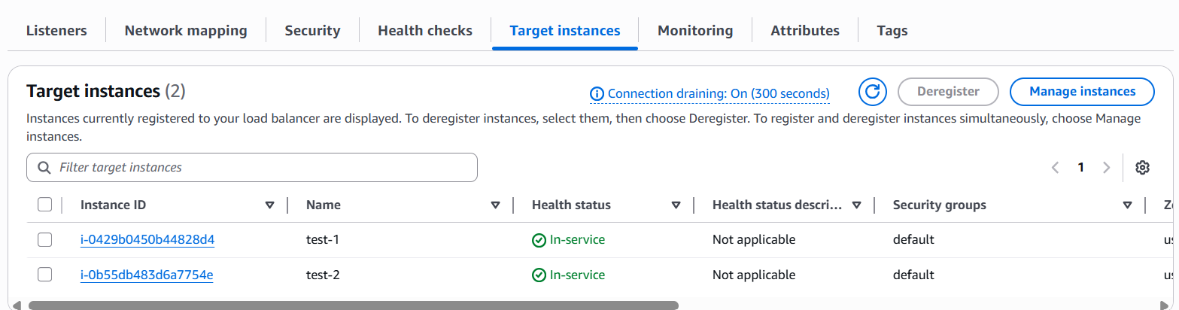

3. Copy the **DNS Name** of the load balancer
4. Access the DNS name in a browser

5. Stop one EC2 instance and verify traffic continues via remaining instance

6. Conclusion

The AWS Classic Load Balancer was successfully configured and validated, ensuring reliable traffic distribution and high availability for the application.

- Configure Application Load balancer.

1. Task Title

Configure AWS Application Load Balancer (ALB)

2. Objective

To configure an AWS Application Load Balancer that routes HTTP/HTTPS traffic to backend EC2 instances or targets based on request rules, ensuring scalability, high availability, and improved application performance.

3. Prerequisites

Before starting, ensure the following are available:

* An active AWS account
* A **VPC** with at least two **public subnets** in different Availability Zones
* EC2 instances or containers running a web application
* Target instances listening on a specific port (e.g., 80 or 8080)
* Security group allowing inbound HTTP/HTTPS traffic
* IAM user/role with ELB and EC2 permissions

4. Step-by-Step Implementation

### Step 1: Navigate to Load Balancers

1. Log in to the AWS Management Console
2. Go to **EC2 → Load Balancers**
3. Click **Create Load Balancer**

### Step 2: Choose Load Balancer Type

1. Select **Application Load Balancer**
2. Click **Create**

### Step 3: Configure Load Balancer Settings

1. Enter a **Load Balancer Name**
2. Choose **Internet-facing** or **Internal**
3. Select **IPv4** or **Dualstack**
4. Select the **VPC**
5. Choose at least **two Availability Zones and subnets**

### Step 4: Configure Security Groups

1. Assign an existing security group or create a new one
2. Allow inbound traffic on ports **80 (HTTP)** and/or **443 (HTTPS)**

### Step 5: Configure Listeners

1. Create a listener (e.g., HTTP on port 80)
2. Choose a default action → **Forward to target group**

### Step 6: Create a Target Group

1. Choose target type: **Instance / IP / Lambda**
2. Enter a **Target Group Name**
3. Select protocol and port (e.g., HTTP:80)
4. Configure **Health Check** settings

* Protocol: HTTP
* Path: `/` or `/health`
5. Click **Next**

### Step 7: Register Targets

1. Select EC2 instances or IPs
2. Add them to the target group
3. Click **Create Target Group**

### Step 8: Review and Create ALB

1. Review all configurations
2. Click **Create Load Balancer**

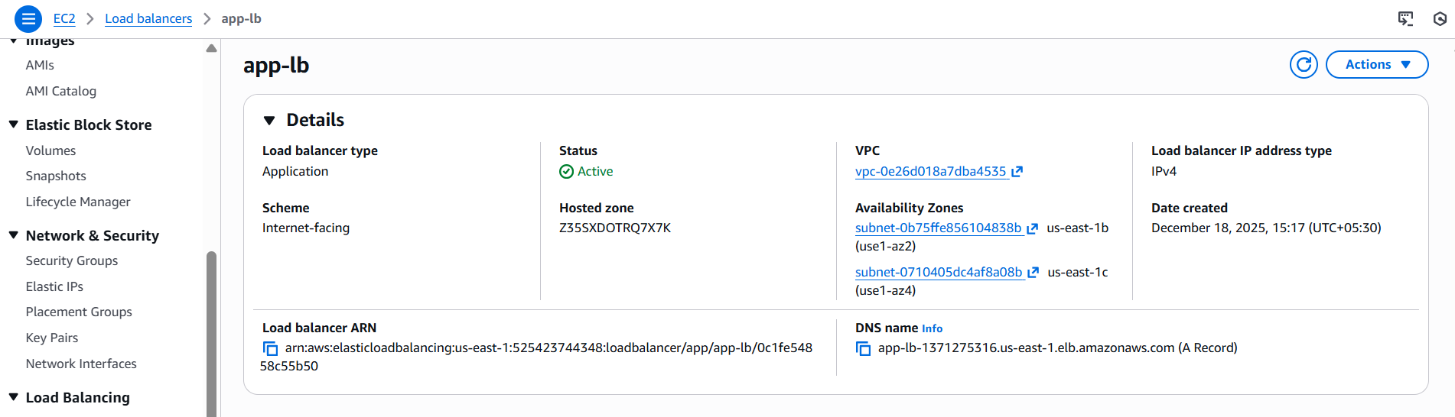

5. Validation Steps

1. Verify ALB state shows **Active**
2. Check **Target Group → Targets** are **Healthy**
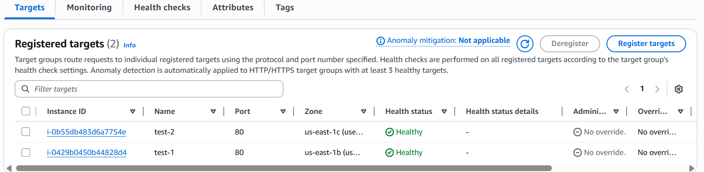

3. Copy the **ALB DNS Name**
4. Access the DNS name in a web browser
5. Confirm the application responds correctly
6. Conclusion

The AWS Application Load Balancer was successfully configured and validated, providing scalable, secure, and highly available application traffic routing.

- Configure Network Load balancer.

1. Task Title

Configure AWS Network Load Balancer (NLB)

2. Objective

To configure an AWS Network Load Balancer that distributes TCP/UDP traffic across backend targets with ultra-low latency, high throughput, and high availability.

3. Prerequisites

Before starting, ensure the following are available:

* An active AWS account
* A **VPC** with at least two subnets in different Availability Zones
* EC2 instances or services listening on required ports (e.g., TCP 80, 443, or custom ports)
* Security groups on EC2 instances allowing inbound traffic from the NLB
* IAM user/role with permissions for EC2 and Elastic Load Balancing

4. Step-by-Step Implementation

### Step 1: Navigate to Load Balancers

1. Log in to the AWS Management Console
2. Go to **EC2 → Load Balancers**
3. Click **Create Load Balancer**

### Step 2: Choose Load Balancer Type

1. Select **Network Load Balancer**
2. Click **Create**

### Step 3: Configure Load Balancer Settings

1. Enter a **Load Balancer Name**
2. Choose **Internet-facing** or **Internal**
3. Select **IPv4** or **Dualstack**
4. Select the **VPC**
5. Choose at least **two subnets** (one per Availability Zone)

### Step 4: Configure Listeners

1. Add a listener (e.g., TCP on port 80 or 443)
2. Choose **Forward to target group** as the default action

### Step 5: Create a Target Group

1. Choose target type: **Instance / IP / Application Load Balancer**
2. Enter a **Target Group Name**
3. Select protocol and port (TCP/UDP/TLS)
4. Configure **Health Check** settings

* Protocol: TCP or HTTP (if supported)
* Port: traffic port
5. Click **Next**

### Step 6: Register Targets

1. Select EC2 instances or IP addresses
2. Add them to the target group
3. Click **Create Target Group**

### Step 7: Review and Create NLB

1. Review all configurations
2. Click **Create Load Balancer**

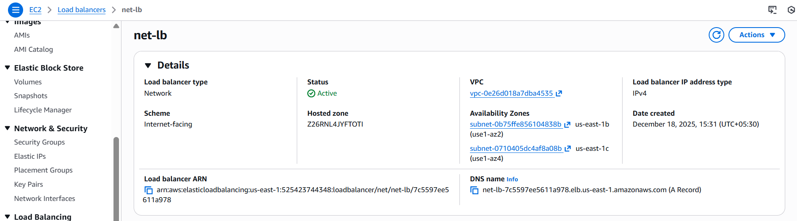
5. Validation Steps

1. Verify the NLB status shows **Active**
2. Check **Target Group → Targets** are **Healthy**
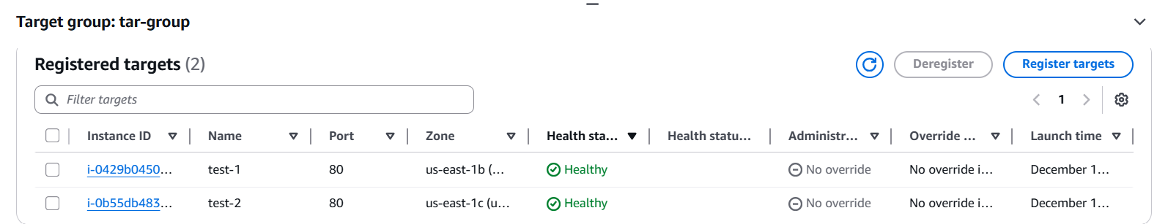
3. Copy the **NLB DNS Name**
4. Test connectivity using browser, curl, or telnet

6. Conclusion

The AWS Network Load Balancer was successfully configured and validated, ensuring low-latency and highly available network traffic distribution.

- Map and Attach SSL for Application Load balancer Route-53.

1. Task Title

Map Route 53 Domain and Attach SSL to Application Load Balancer

2. Objective

To map a custom domain from Amazon Route 53 to an Application Load Balancer and secure it by attaching an SSL/TLS certificate, enabling HTTPS access.

3. Prerequisites

Before starting, ensure the following are available:

* An active AWS account
* An existing **Application Load Balancer** in **Active** state
* A registered **domain name**
* A **public hosted zone** created in Amazon Route 53
* An **SSL certificate issued in AWS Certificate Manager (ACM)** for the domain
* A target group with **healthy targets**
* ALB security group allowing inbound **HTTPS (443)** and optionally **HTTP (80)**
* IAM user/role with permissions for ELB, ACM, and Route 53

4. Step-by-Step Implementation

### Step 1: Request SSL Certificate from ACM

1. Open **AWS Certificate Manager (ACM)**
2. Click **Request a certificate** → **Public certificate**
3. Enter domain name (e.g., `example.com`, `www.example.com`)
4. Choose **DNS validation**
5. Add the provided DNS records in Route 53
6. Ensure certificate status becomes **Issued**

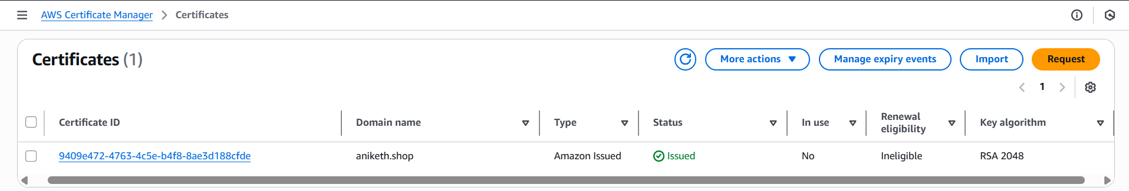

### Step 2: Attach SSL Certificate to ALB

1. Go to **EC2 → Load Balancers**
2. Select the **Application Load Balancer**
3. Open the **Listeners** tab
4. Click **Add listener**
5. Configure:

* Protocol: **HTTPS**
* Port: **443**
* Default action: **Forward to target group**
6. Select **ACM certificate**
7. Choose the issued SSL certificate
8. Save changes

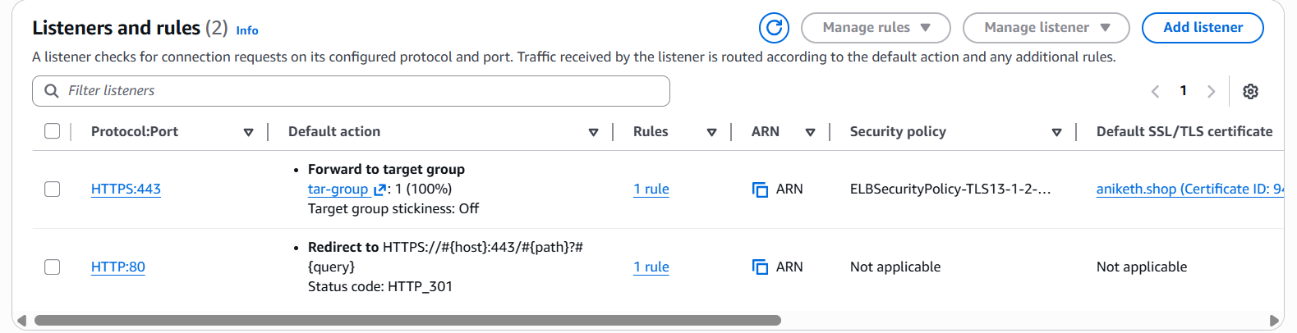

### Step 3: (Optional) Configure HTTP to HTTPS Redirect

1. Edit the **HTTP (80)** listener
2. Change default action to **Redirect**
3. Set:

* Protocol: HTTPS
* Port: 443
* Status code: 301 (Permanent)
4. Save changes

### Step 4: Map ALB to Route 53

1. Go to **Route 53 → Hosted zones**
2. Select the public hosted zone for your domain
3. Click **Create record**
4. Configure record:

* Record name: `www` or leave blank for root domain
* Record type: **A – IPv4 address**
* Alias: **Yes**
* Alias target: **Application Load Balancer**
* Select correct region and ALB
5. Click **Create records**

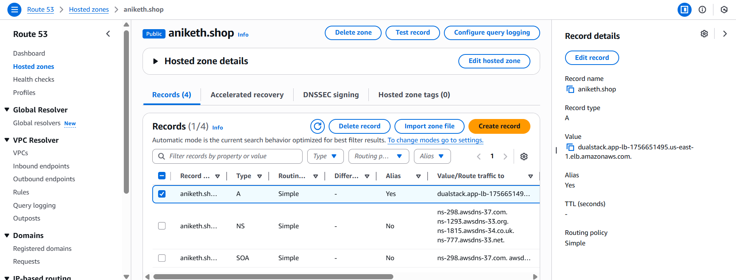

5. Validation Steps

1. Confirm SSL certificate status in ACM shows **In use**
2. Verify HTTPS listener on ALB is **Active**
3. Wait for DNS propagation (few minutes)
4. Access `https://your-domain.com` in a browser
5. Confirm **secure lock icon** is visible
6. Verify HTTP URL redirects to HTTPS (if configured)

6. Conclusion

The domain was successfully mapped to the Application Load Balancer using Route 53, and SSL was attached, enabling secure HTTPS access to the application.

- Push the Application Load balancer logs to S3.

1. Task Title

Enable and Push Application Load Balancer Logs to Amazon S3

2. Objective

To enable access logging for an Application Load Balancer and store the logs securely in an Amazon S3 bucket for monitoring, auditing, and troubleshooting.

3. Prerequisites

Before starting, ensure the following are available:

* An active AWS account
* An existing **Application Load Balancer** in **Active** state
* An **Amazon S3 bucket** in the same AWS region as the ALB
* Required **S3 bucket policy** allowing ALB to write logs
* IAM user/role with permissions for ELB and S3

4. Step-by-Step Implementation

### Step 1: Create or Identify S3 Bucket

1. Go to **Amazon S3 → Buckets**
2. Create a new bucket or use an existing one
3. Ensure bucket region matches the **ALB region**
4. Note the bucket name (e.g., `alb-access-logs-bucket`)

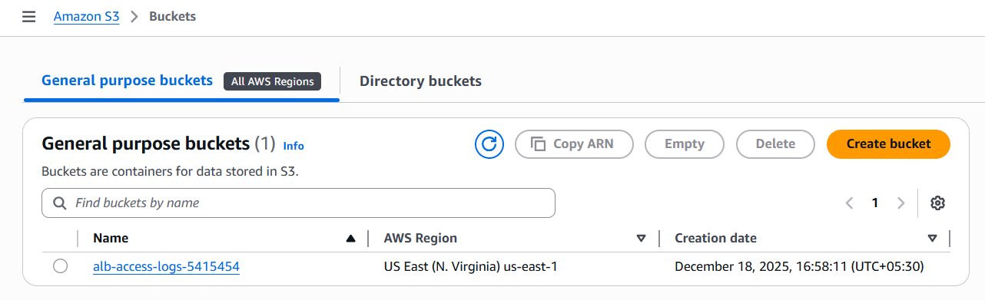

### Step 2: Apply S3 Bucket Policy for ALB Logs

1. Open the S3 bucket
2. Go to **Permissions → Bucket policy**
3. Add the following policy (replace values accordingly):

> **Important:** Replace `YOUR_BUCKET_NAME` and `YOUR_REGION`
```json
{
"Version": "2012-10-17",
"Statement": [
{
"Effect": "Allow",
"Principal": {
"Service": "logdelivery.elasticloadbalancing.amazonaws.com"
},
"Action": "s3:PutObject",
"Resource": "arn:aws:s3:::alb-access-logs-bucket/AWSLogs/ACCOUNT-ID/*"
}
]
}
```
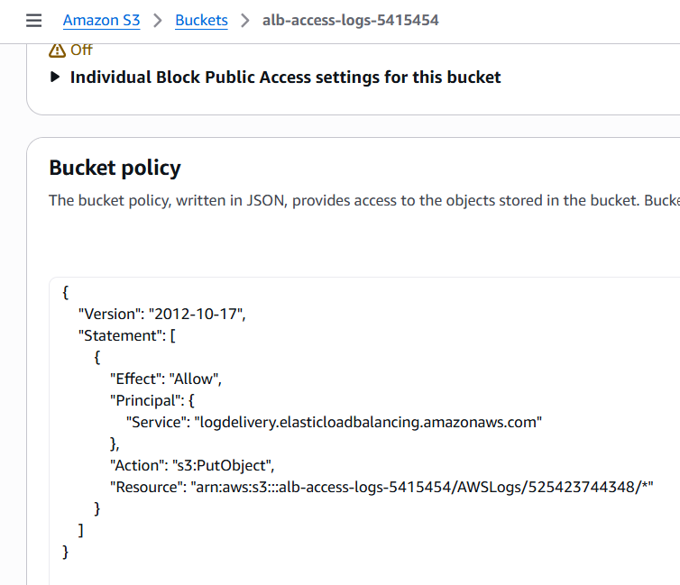

### Step 3: Enable Access Logs on ALB

1. Go to **EC2 → Load Balancers**
2. Select the **Application Load Balancer**
3. Open the **Attributes** tab
4. Click **Edit attributes**
5. Enable **Access logs**
6. Enter:

* S3 bucket: `alb-access-logs-bucket`
* Prefix (optional): `alb-logs`
7. Save changes

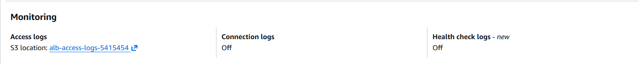

### Step 4: Verify Logging Configuration

1. Ensure access logging status shows **Enabled**
2. Confirm bucket and prefix values are correct

5. Validation Steps

1. Generate traffic to the ALB (browser or curl)
2. Go to **Amazon S3 → Bucket → Prefix path**
3. Verify log files are created under:

```
AWSLogs/ACCOUNT-ID/elasticloadbalancing/region/
```
4. Download a log file and confirm ALB request entries
5. Check timestamps to verify new logs are being written

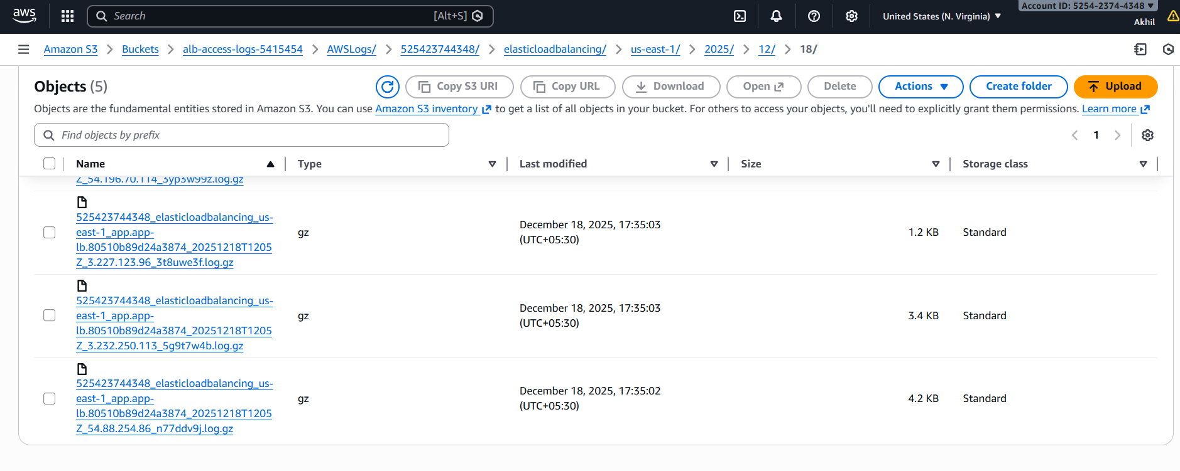
6. Conclusion

Application Load Balancer access logging was successfully enabled and logs are now being delivered to Amazon S3 for monitoring and analysis.

